English Vocabulary: The Weather

1. Vocabulary (nouns)

 | Sun | 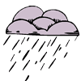 | Rain  Shower
 | Wind |  | Snow
 | Cloud |  | Storm  (Thunderstorm)
 | Drought | 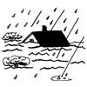 | Flood
 | Weather forecast | 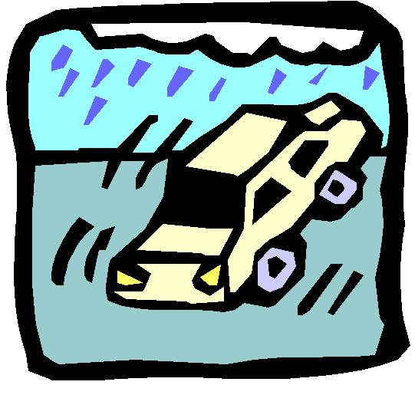 | Hurricane
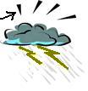 | Thunder | 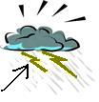 | Lightning
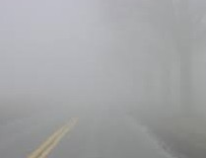 | Fog |  | Drizzle

2. Describing the weather (adjectives/verbs)
Q: What's the weather like today?
A: It's ____________________ .

 | It's sunny. |  | It's rainy.  It’s raining.  It's wet.
 | It's windy. |  | It's snowy.  It’s snowing.
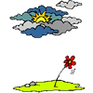 | It's cloudy. |  | It's stormy.
 | It's warm.  It's hot.  It’s very hot.  It’s boiling. |  | It's cool.  It's cold.  It’s very cold.  It’s freezing.
 | It's humid. |  | It's dry.
 | It’s foggy. |  | It’s drizzly.  It’s drizzling.

Present/Past/Future
Today: Q: What is the weather like today?
A: It is ____________________ .
Yesterday: Q: What was the weather like yesterday?
A: It was ____________________ .
Tomorrow: Q: What will the weather be like tomorrow?
A: (I think) It will be ____________________ .

3. Temperature
Q: What's the temperature today? A: It's ____________________ .
Examples: 30^{O}C = It’s 30 degrees Centigrade.
58^{O}F = It’s 58 degrees Fahrenheit.
-10^{O}C = It’s minus 10 degrees Centigrade. / It’s 10 degrees below zero.
0^{O}F = It’s zero degrees Fahrenheit.
^{O}C = degrees Centigrade/Celsius, ^{O}F = degrees Fahrenheit (only in the USA!)
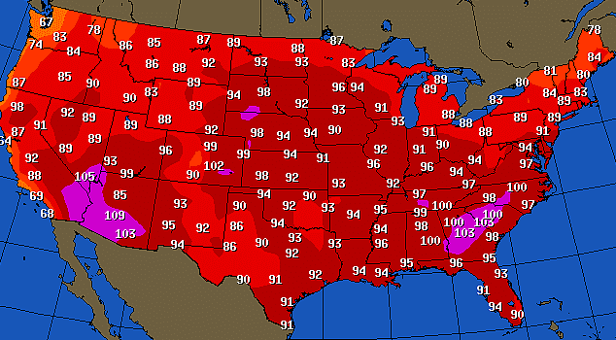

Weather map in the
USA on July 27th, 2020:

Temperature adjectives (^{O}C):
> 40^{O} boiling
35-40^{O} very hot
30-35^{O} hot
20-30^{O} warm
15-20^{O} fresh / cool / chilly
10-15^{O} cold
0-10^{O} very cold
< 0^{O} freezing

How do we say “Sensação térmica” in English?
We say “wind chill” or “it feels like”:
- The actual temperature today is 10 degrees, but the wind chill is 5 degrees.
- The actual temperature today is 10 degrees, but it feels like it’s 5 degrees.

Video: https://english.insl.com.br/files/videos/Feels-like.mp4 (short)
Exercise

Q: What's the weather like today? Q: What's the temperature today?
A: It's ____________________ . A: It's ____________________ .

It’s _________________ | 36^{O}C  It’s _______________________
It’s _________________ | 14^{O}C  It’s _______________________
It’s _________________ | 20^{O}C  It’s _______________________
It’s _________________ | 8^{O}C  It’s _______________________

