
English vocabulary: “will”


1) Future Simple (auxiliary verb)
- I think it will rain tomorrow. (prediction)
- One day, I will be old. (fact)
- Will you have some more tea? (offer)
- Will you please be quiet! (polite demand)
- Will you close the window? (request)
- I will call you when I arrive. (promise)
- If it doesn’t rain, I will go to the beach on Saturday. (possibility)
- A: “I’m really hungry!” B: “OK! I will make some sandwiches.” (reaction)

2) Testament (noun)
- I am getting old. I should make a will.
- We have a meeting with my lawyer tomorrow about my
father’s will.
- Yesterday, the lawyer read the contents of the will, and
nobody was happy!


3) to intend / intention (verb / noun) (PT: vontade / intenção / disposição)
- I’ve lost the will to study. (perdi a vontade)
- Are you willing to run the risk? (disposto)
- If it is God’s will, then I will survive. (vontade de Deus)
- It is uncertain if the action was willed or not. (intencional)
- Will you come with me willingly? (por vontade)
- He forced me to drive against my will. (contra a minha vontade)
- He forced me to drive unwillingly. (contra a minha vontade)
- He doesn’t show willingness to perform well. (disposição / boa vontade)
- He willfully defied the teachers. (por vontade próprio / intencionalmente)
- He is an extremely willful person. (obstinado / teimoso / cheio de vontade)

4) Other vocabulary and expressions
- I will succeed, God willing. (se Deus quiser)
- I got better by the will of God. (pela vontade de Deus)
- He doesn’t have the willpower to continue. (força de vontade)
- The problem of AI is how to give computers free will. (livre arbítrio)
- Where there’s a will, there’s a way. (ditado)
- “Donald Trump is a puppet for the Russians”, if you will. (se você me entende)

Video: https://english.insl.com.br/files/videos/If-you-will.mp4 (short)

The definition of “will” (Wikipedia)
Will, within philosophy, is a faculty of the mind. It is as important as “reason” and “understanding”. It is considered to be central to the field of ethics because of its role in enabling deliberate action. We often say “the human will” or “man’s will” to refer to the ability of people to follow and act on their own thoughts and ideas.
Exercise 1. The following is an extract from “The Book of Why” by Judea Pearl. The theme of the chapter is AI.
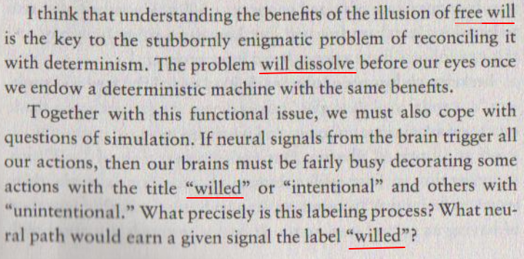

What are the meanings of the underlined words/phrases?
1) “free will” ___________________________
2) “will dissolve” ___________________________
3) “willed” (x2) ___________________________

Exercise 2. The following is an extract from “A Short History of the World” by H. G. Wells (1922). Look at the highlighted sentence which contains the words “will can”. As you know, the future form “will can” doesn’t exist in English. For example:
He will can go tomorrow.
He will be able to go tomorrow.
So can you explain this sentence?







