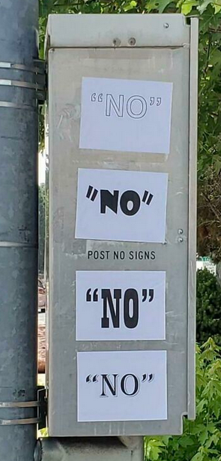

English Vocabulary: ‘no’, ‘not’, ‘non-’ (PT: não)

1) no
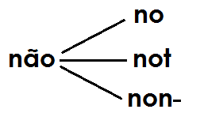
a) Response (opposite of ‘yes’)
- Would you like some cake? No, thanks.
- Do you like sushi? No, I don’t.

b) Zero quantity (no + noun)
- I have many books. Peter has no books.
- I have two cars. Peter has no cars.
- I have a lot of money. Peter has no money.
- Please put no posters on the classroom walls.

c) Prohibition (no + noun)
- There is no smoking here.
- No entry!
- No running in the corridors.
- Ssshh! No talking!

2) not / n’t

a) Negative phrases
- I’m not French.
- Cigarettes aren’t healthy.
- Peter doesn’t have a car.
- We don’t go to the cinema.

b) Prohibition (do not / don’t + verb)
- Please don’t smoke here.
- Do not enter.
- Don’t run in the corridors.
- Don’t talk loudly.

3) non-

Opposites
- (Restaurant) Good evening sir. Smoking or non-smoking?
- I always use non-stick pans.
- He is a non-believer. He is an atheist.
- We prefer non-stop flights. (non-stop = direct)
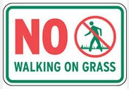
More examples of “no”:

No students arrived yesterday.

I have no free time on Mondays.

No idea!

No doubt. ("Sem dúvida.")

No way! ("De jeito nenhum!")
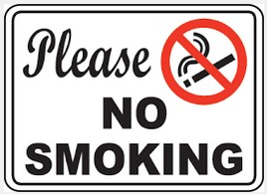
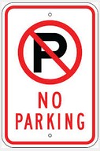



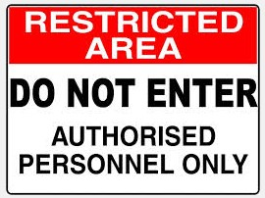
More examples of “not/n’t”:

I am free today, but I'm not free tomorrow.
(or: I am free today, but not tomorrow.)

Cats are independent, but dogs are not.
Cats are independent, but not dogs.

I haven't seen John recently.

I didn't see John yesterday.

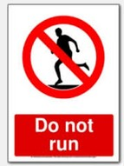
I can't play guitar.

A: You must not speak loudly.
B: Why not?
A: Because it isn't permitted – this is a library!

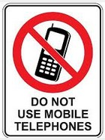
Exercise 1. Complete with no, not, don’t, doesn’t or non-.
1. a) I like meat, but I __________ like fish.
b) I like meat, but __________ fish.
2. She was __________ happy when he arrived late.
3. OMG! I have __________ money in my bank account!
4. They repaired the door but __________ very well.
5. He hates sports. He is totally __________ competitive.
6. Hurry, hurry! We have __________ time to lose!
7. I will go to the party, but __________ yet.
8. She is a __________ drinker. She is very religious.
9. My brother did __________ help me yesterday. He is so lazy!
10. a) Sign on a door: “______ SMOKING”
b) Sign on a door: “PLEASE DO ______ SMOKE”
11. a) I have __________ children.
b) I __________ have children.
12. A: “Do you smoke?” B: “________________.” (3 words)
13. A: “Do you smoke?” B: “Yes, but __________ when I'm working.”
14. It’s OK – you can take this drug – it’s a __________ addictive drug.
15. A: “Does he like music?” B: “Yes, but he __________ like rap music!”
16. a) A: “Do you have any money?” B: “Yes, but I __________ have much.”
b) A: “Do you have any money?” B: “Yes, but __________ much.”
c) A: “Do you have any money?” B: “Sorry, I have __________ money.”

Exercise 2. Write the following in an alternative way.
Example: “Do not run” → “No running”
1. No Entry ____________________________
2. No Smoking ____________________________
3. No Parking ____________________________
4. Do not walk here ____________________________
5. Do not drink on the bus ____________________________
6. Do not speak loudly ____________________________

