English Vocabulary – Safety vs Security
The words ‘safe’ and ‘secure’ both translate to ‘seguro’ in Portuguese. Similarly, ‘safety’ and ‘security’ translate to ‘segurança’. However, these words are used in different situations.

1) safe (adjective) / safety (noun/adjective) / safely (adverb)
These words are used when we think about the protection of people. They are about minimizing danger to people. Here are some examples:

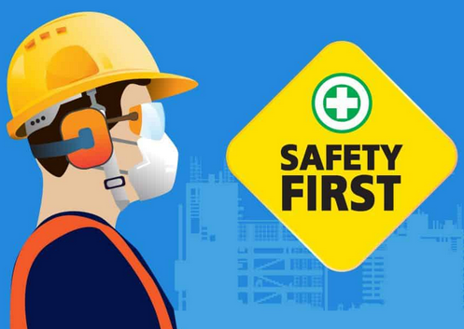
- Don’t worry, we are safe here.
- It is not safe to use the elevator when there is a fire.
- It is not safe to drive too fast.
- Walking on thin ice is not a safe thing to do.
- Car manufacturers are obliged to make their cars safe.

- When climbing a mountain, it is recommended to
use safety equipment.
- It is important to think about safety when you are driving.
- The safety of the driver and of the passengers is
extremely important.

- Please drive safely!
- He walked safely across the road.

The following situations consider safety:
- We must use seatbelts in a car.
- We should drive within the speed limits.
- Aircraft should undergo regular maintenance to reduce the risk of accidents.
- Children shouldn’t cross the road without supervision.

2) secure (adjective) / security (noun/adjective) / securely (adverb)
These words are used when we think about the protection of things or places. They are about minimizing risk to objects or places. Here are some examples:

- Prisons must be secure.

- Banks are very secure places.
- Your house should be secure. Install alarms and cameras.
- Not all e-mail software programs are secure.

- Bank vaults require a security code to enter.
- The police monitor airports for security reasons.
- Banks and stores often employ security guards.
- If you live in a house, you should think about security.
- US air companies employ air marshals as a security
measure.
- Most establishments use security cameras.

- Fasten your seatbelt securely.
- Your house should be securely protected.

Sometimes we can use both ideas together. For example:
- Secure your car to keep the people safe.
- Cars have safety equipment to prevent injury and security systems to prevent theft.
- You must fasten your seat belt securely for your safety.
- If your house is secure, your family is safe.

Exercise 1. Complete the sentences below with ‘safe’, ‘safety’, ‘safely’, ‘secure’, ‘security’ or ‘securely’:
1. Wife: I feel very _____________________ in your arms !

2. I trust the bank to conduct _____________________ transactions.

3. Please carry my baby _____________________ !

4. All airports carry out _____________________ checks on all passengers.

5. Bungee jump instructor:
“You don’t need to worry. We have all the necessary _____________________ equipment.”

6. Please fasten your seatbelt _____________________ before we take off. This is for your ____________.

Notes

1. The noun “seguro” can also translate to “insurance”, which is a financial contract for accidental damage, injury or death. For example:

- Car insurance
- House insurance
- Health insurance
- Dental insurance
- Life insurance
- Pet insurance

2. The words ‘secure’ and ‘security’ can also be used for jobs and relationships, meaning that they are ‘solid’ and are expected to endure for a long time.
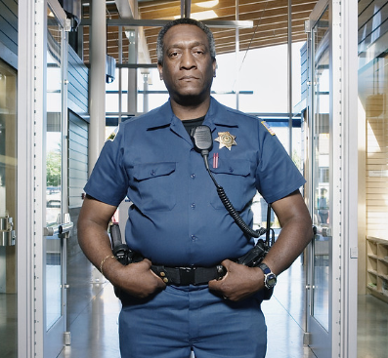
Exercise 2. Do these images represent “safety” or “security” or both?

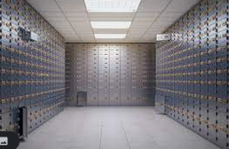
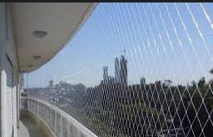

1. _____________________ 2. _____________________

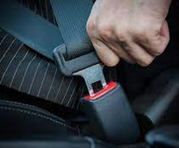


3. _____________________ 4. _____________________

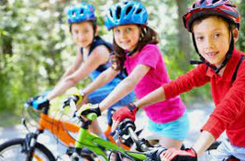


5. _____________________ 6. _____________________

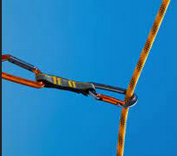

7. _____________________ 8. _____________________

